ASSIGNMENT SET 6

- Simulate the undo and redo option in word packages using a doubly linked list.

#include <stdio.h>
#include <stdlib.h>
#include <string.h>

struct node {
char text[100];
struct node *prev, *next;
};

struct node *head = NULL, *cur = NULL;

void add(char s[]) {
struct node *n = malloc(sizeof(struct node));
strcpy(n->text, s);
n->prev = cur;
n->next = NULL;

if (cur != NULL) {
struct node *p = cur->next;
while (p != NULL) {
struct node *t = p;
p = p->next;
free(t);
}
cur->next = n;
} else {
head = n;
}

cur = n;
}

void undo() {
if (cur != NULL) cur = cur->prev;
else printf("Nothing to undo\n");
}

void redo() {
if (cur != NULL && cur->next != NULL)
cur = cur->next;
else printf("Nothing to redo\n");
}

void display() {
if (cur == NULL) printf("Document is empty\n");
else printf("Current text: %s\n", cur->text);
}

int main() {
int ch;
char s[100];

while (1) {
printf("\n1.Add 2.Undo 3.Redo 4.Display 5.Exit\n");
printf("Enter choice: ");
scanf("%d", &ch);

switch (ch) {
case 1:
printf("Enter text: ");
scanf(" %99[^\n]", s);
add(s);
break;
case 2: undo(); break;
case 3: redo(); break;
case 4: display(); break;
case 5: return 0;
default: printf("Invalid choice\n");
}
}
}

OUTPUT:

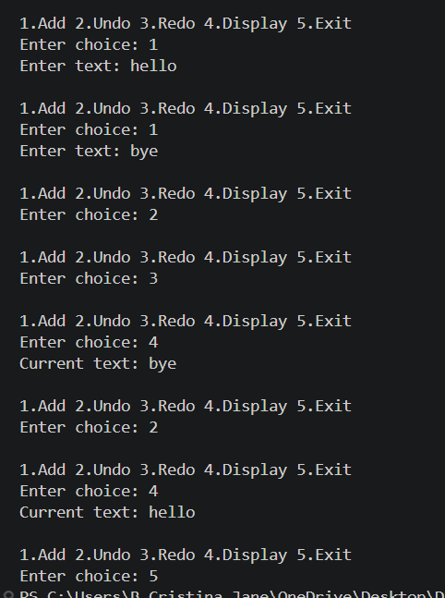

- Given two sorted lists L1 and L2, write a procedure to compute L1 ∩ L2 and L1 ∪ L2 using basic list operations.

#include <stdio.h>

int main() {
int a[50], b[50], u[100], in[50];
int n, m, i = 0, j = 0, k = 0, p = 0;

printf("Enter size of L1: ");
scanf("%d", &n);
printf("Enter sorted elements of L1: ");
for (int x = 0; x < n; x++) scanf("%d", &a[x]);

printf("Enter size of L2: ");
scanf("%d", &m);
printf("Enter sorted elements of L2: ");
for (int x = 0; x < m; x++) scanf("%d", &b[x]);

while (i < n && j < m) {
if (a[i] < b[j]) u[k++] = a[i++];
else if (a[i] > b[j]) u[k++] = b[j++];
else {
u[k++] = a[i];
in[p++] = a[i];
i++;
j++;
}
}

while (i < n) u[k++] = a[i++];
while (j < m) u[k++] = b[j++];

printf("L1 intersection L2: ");
for (i = 0; i < p; i++) printf("%d ", in[i]);

printf("\nL1 union L2: ");
for (i = 0; i < k; i++) {
if (i == 0 || u[i] != u[i - 1])
printf("%d ", u[i]);
}
printf("\n");
return 0;
}

OUTPUT:

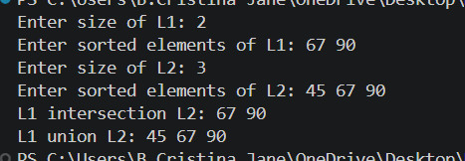

- Swap two elements by adjusting only the pointers (and not the data) using doubly linked list.

#include <stdio.h>
#include <stdlib.h>

struct node {
int data;
struct node *prev, *next;
};

struct node *head = NULL;

void insert(int x) {
struct node *n = malloc(sizeof(struct node));
n->data = x;
n->next = NULL;
n->prev = NULL;

if (head == NULL) head = n;
else {
struct node *t = head;
while (t->next != NULL) t = t->next;
t->next = n;
n->prev = t;
}
}

void display() {
struct node *t = head;
while (t != NULL) {
printf("%d ", t->data);
t = t->next;
}
printf("\n");
}

/* Swap nodes by changing links, not data */
void swapNodes(int x, int y) {
struct node *a = head, *b = head;

while (a && a->data != x) a = a->next;
while (b && b->data != y) b = b->next;

if (!a || !b || a == b) return;

if (a->next == b) {
struct node *p = a->prev, *n = b->next;
if (p) p->next = b;
else head = b;
if (n) n->prev = a;
b->prev = p; b->next = a;
a->prev = b; a->next = n;
} else if (b->next == a) {
swapNodes(y, x);
return;
} else {
struct node *ap = a->prev, *an = a->next;
struct node *bp = b->prev, *bn = b->next;

if (ap) ap->next = b;
else head = b;
if (an) an->prev = b;
if (bp) bp->next = a;
else head = a;
if (bn) bn->prev = a;

a->prev = bp; a->next = bn;
b->prev = ap; b->next = an;
}
}

int main() {
int n, x, y, v;

printf("Enter number of nodes: ");
scanf("%d", &n);
printf("Enter elements: ");
for (int i = 0; i < n; i++) {
scanf("%d", &v);
insert(v);
}

printf("Enter two elements to swap: ");
scanf("%d%d", &x, &y);
swapNodes(x, y);

printf("List after swapping: ");
display();
return 0;
}

OUTPUT:

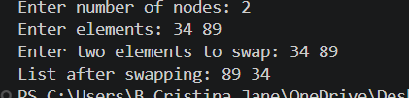

4. Write an array implementation of self adjusting lists. A self adjusting list is like a regular list, except that all insertions are performed at the front and when an element is accessed by a find, it is moved to the front of the list, without changing the relative order of the other elements.

#include <stdio.h>

int main() {
int a[100], n, choice, x, i, pos, temp;

printf("Enter number of elements: ");
scanf("%d", &n);

printf("Enter elements: ");
for (i = 0; i < n; i++) {
scanf("%d", &a[i]);
}

while (1) {
printf("\n1. Insert at front");
printf("\n2. Find element");
printf("\n3. Display list");
printf("\n4. Exit");
printf("\nEnter choice: ");
scanf("%d", &choice);

switch (choice) {
case 1:
printf("Enter element: ");
scanf("%d", &x);

for (i = n; i > 0; i--) {
a[i] = a[i - 1];
}

a[0] = x;
n++;
break;

case 2:
printf("Enter element to find: ");
scanf("%d", &x);

for (pos = 0; pos < n; pos++) {
if (a[pos] == x)
break;
}

if (pos == n) {
printf("Element not found\n");
} else {
temp = a[pos];

for (i = pos; i > 0; i--) {
a[i] = a[i - 1];
}

a[0] = temp;
printf("Element found and moved to front\n");
}
break;

case 3:
printf("List: ");
for (i = 0; i < n; i++) {
printf("%d ", a[i]);
}
printf("\n");
break;

case 4:
return 0;

default:
printf("Invalid choice\n");
}
}

return 0;
}

OUTPUT:

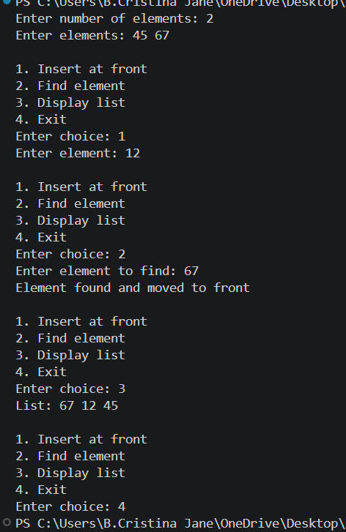

- Write a C program to reverse a given doubly linked list.

#include <stdio.h>
#include <stdlib.h>

struct node {
int data;
struct node *prev, *next;
};

struct node *head = NULL;

void insert(int x) {
struct node *n = malloc(sizeof(struct node));
n->data = x;
n->next = NULL;
n->prev = NULL;

if (head == NULL) head = n;
else {
struct node *t = head;
while (t->next) t = t->next;
t->next = n;
n->prev = t;
}
}

void reverse() {
struct node *t = head, *temp = NULL;

while (t != NULL) {
temp = t->prev;
t->prev = t->next;
t->next = temp;
t = t->prev;
}

if (temp != NULL) head = temp->prev;
}

void display() {
struct node *t = head;
while (t) {
printf("%d ", t->data);
t = t->next;
}
printf("\n");
}

int main() {
int n, x;
printf("Enter number of nodes: ");
scanf("%d", &n);

printf("Enter elements: ");
for (int i = 0; i < n; i++) {
scanf("%d", &x);
insert(x);
}

printf("Original list: ");
display();
reverse();
printf("Reversed list: ");
display();

return 0;
}

OUTPUT:

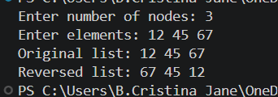

- Write a C program to delete the middle element of a DLL.
#include <stdio.h>
#include <stdlib.h>

struct node {
int data;
struct node *prev, *next;
};

struct node *head = NULL;

void insert(int x) {
struct node *n = malloc(sizeof(struct node));
n->data = x;
n->next = NULL;
n->prev = NULL;

if (!head) head = n;
else {
struct node *t = head;
while (t->next) t = t->next;
t->next = n;
n->prev = t;
}
}

void deleteMiddle() {
if (!head) {
printf("List is empty\n");
return;
}

struct node *slow = head, *fast = head;

while (fast && fast->next) {
slow = slow->next;
fast = fast->next->next;
}

if (slow->prev) slow->prev->next = slow->next;
else head = slow->next;

if (slow->next) slow->next->prev = slow->prev;

free(slow);
}

void display() {
struct node *t = head;
while (t) {
printf("%d ", t->data);
t = t->next;
}
printf("\n");
}

int main() {
int n, x;
printf("Enter number of nodes: ");
scanf("%d", &n);

printf("Enter elements: ");
for (int i = 0; i < n; i++) {
scanf("%d", &x);
insert(x);
}

deleteMiddle();
printf("List after deleting middle element: ");
display();
return 0;
}

OUTPUT:
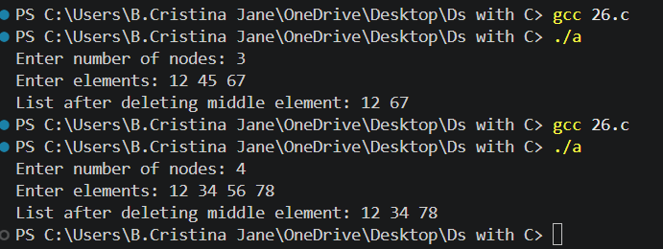

7.Remove duplicate elements from a (i) sorted DLL (ii) unsorted DLL.

#include <stdio.h>
#include <stdlib.h>

struct node {
int data;
struct node *prev, *next;
};

struct node *head = NULL;

void insert(int x) {
struct node *n = malloc(sizeof(struct node));
n->data = x;
n->next = NULL;
n->prev = NULL;

if (!head) head = n;
else {
struct node *t = head;
while (t->next) t = t->next;
t->next = n;
n->prev = t;
}
}

void removeDuplicates() {
struct node *p = head;

while (p) {
struct node *q = p->next;
while (q) {
if (p->data == q->data) {
struct node *del = q;
q = q->next;

if (del->prev) del->prev->next = del->next;
if (del->next) del->next->prev = del->prev;
free(del);
} else {
q = q->next;
}
}
p = p->next;
}
}

void display() {
struct node *t = head;
while (t) {
printf("%d ", t->data);
t = t->next;
}
printf("\n");
}

int main() {
int n, x;
printf("Enter number of nodes: ");
scanf("%d", &n);
printf("Enter elements: ");

for (int i = 0; i < n; i++) {
scanf("%d", &x);
insert(x);
}

removeDuplicates();
printf("List after removing duplicates: ");
display();
return 0;
}

OUTPUT:

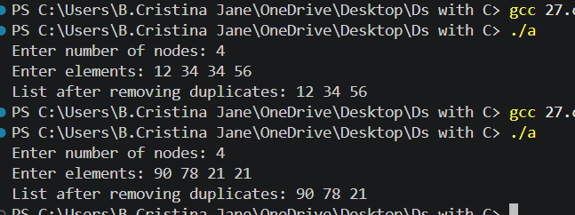

8. Calculate the frequency count of a given integer in a circular DLL.

#include <stdio.h>
#include <stdlib.h>

struct node {
int data;
struct node *prev, *next;
};

struct node *head = NULL;

void insert(int x) {
struct node *n = malloc(sizeof(struct node));
n->data = x;

if (head == NULL) {
head = n;
n->next = n;
n->prev = n;
} else {
struct node *last = head->prev;
n->next = head;
n->prev = last;
last->next = n;
head->prev = n;
}
}

int main() {
int n, x, key, count = 0;
struct node *t;

printf("Enter number of nodes: ");
scanf("%d", &n);

printf("Enter elements: ");
for (int i = 0; i < n; i++) {
scanf("%d", &x);
insert(x);
}

printf("Enter element to count: ");
scanf("%d", &key);

if (head != NULL) {
t = head;
do {
if (t->data == key) count++;
t = t->next;
} while (t != head);
}

printf("Frequency count: %d\n", count);
return 0;
}

OUTPUT:

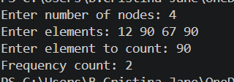

9. Search for a particular element in a binary tree.

#include <stdio.h>
#include <stdlib.h>

struct node {
int data;
struct node *left, *right;
};

struct node *create(int a[], int i, int n) {
if (i >= n) return NULL;

struct node *root = malloc(sizeof(struct node));
root->data = a[i];
root->left = create(a, 2 * i + 1, n);
root->right = create(a, 2 * i + 2, n);

return root;
}

int search(struct node *root, int key) {
if (root == NULL) return 0;
if (root->data == key) return 1;

return search(root->left, key) ||
search(root->right, key);
}

int main() {
int a[100], n, key;

printf("Enter number of nodes: ");
scanf("%d", &n);

printf("Enter tree elements: ");
for (int i = 0; i < n; i++)
scanf("%d", &a[i]);

struct node *root = create(a, 0, n);

printf("Enter element to search: ");
scanf("%d", &key);

if (search(root, key))
printf("Element found\n");
else
printf("Element not found\n");

return 0;
}

OUTPUT:

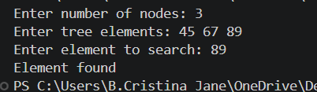

10. Calculate the height or depth of a tree and print it.

#include <stdio.h>
#include <stdlib.h>

struct node {
int data;
struct node *left, *right;
};

struct node *create(int a[], int i, int n) {
if (i >= n) return NULL;

struct node *root = malloc(sizeof(struct node));
root->data = a[i];
root->left = create(a, 2 * i + 1, n);
root->right = create(a, 2 * i + 2, n);

return root;
}

int max(int a, int b) {
return (a > b) ? a : b;
}

int height(struct node *root) {
if (root == NULL) return 0;

return 1 + max(height(root->left),
height(root->right));
}

int main() {
int a[100], n;

printf("Enter number of nodes: ");
scanf("%d", &n);

printf("Enter tree elements: ");
for (int i = 0; i < n; i++)
scanf("%d", &a[i]);

struct node *root = create(a, 0, n);

printf("Height of tree: %d\n", height(root));

return 0;
}

OUTPUT:
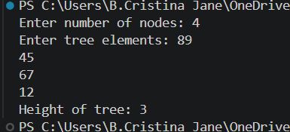

11.Given a binary tree, convert it to a doubly linked list keeping the same order ( inorder traversal)

#include <stdio.h>
#include <stdlib.h>

struct node {
int data;
struct node *left, *right;
};

struct node *head = NULL, *prev = NULL;

struct node *create(int a[], int i, int n) {
if (i >= n)
return NULL;

struct node *root = malloc(sizeof(struct node));
root->data = a[i];
root->left = create(a, 2 * i + 1, n);
root->right = create(a, 2 * i + 2, n);

return root;
}

void convert(struct node *root) {
if (root == NULL)
return;

convert(root->left);

if (prev == NULL)
head = root;
else {
root->left = prev;
prev->right = root;
}

prev = root;

convert(root->right);
}

void display() {
struct node *temp = head;

printf("Doubly linked list: ");
while (temp != NULL) {
printf("%d ", temp->data);
temp = temp->right;
}
printf("\n");
}

int main() {
int a[100], n;

printf("Enter number of nodes: ");
scanf("%d", &n);

printf("Enter tree elements: ");
for (int i = 0; i < n; i++)
scanf("%d", &a[i]);

struct node *root = create(a, 0, n);

convert(root);
display();

return 0;
}

OUTPUT:
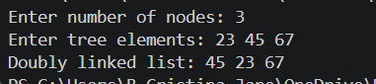

12. Given the binary tree the task is to connect the nodes that are at the same level using next right pointers

#include <stdio.h>
#include <stdlib.h>

struct node {
int data;
struct node *left, *right, *nextRight;
};

struct node *create(int a[], int i, int n) {
if (i >= n)
return NULL;

struct node *root = malloc(sizeof(struct node));
root->data = a[i];
root->left = create(a, 2 * i + 1, n);
root->right = create(a, 2 * i + 2, n);
root->nextRight = NULL;

return root;
}

void connect(struct node *root) {
struct node *queue[100];
int front = 0, rear = 0;

if (root == NULL)
return;

queue[rear++] = root;

while (front < rear) {
int count = rear - front;
struct node *prev = NULL;

for (int i = 0; i < count; i++) {
struct node *cur = queue[front++];

if (prev != NULL)
prev->nextRight = cur;

prev = cur;

if (cur->left != NULL)
queue[rear++] = cur->left;

if (cur->right != NULL)
queue[rear++] = cur->right;
}

prev->nextRight = NULL;
}
}

void display(struct node *root) {
struct node *queue[100];
int front = 0, rear = 0, level = 1;

if (root == NULL)
return;

queue[rear++] = root;

while (front < rear) {
int count = rear - front;

printf("Level %d: ", level++);

for (int i = 0; i < count; i++) {
struct node *cur = queue[front++];

printf("%d ", cur->data);

if (cur->left != NULL)
queue[rear++] = cur->left;

if (cur->right != NULL)
queue[rear++] = cur->right;
}

printf("\n");
}
}

int main() {
int a[100], n;

printf("Enter number of nodes: ");
scanf("%d", &n);

printf("Enter tree elements: ");
for (int i = 0; i < n; i++)
scanf("%d", &a[i]);

struct node *root = create(a, 0, n);

connect(root);

printf("Nodes connected at each level:\n");
display(root);

return 0;
}

OUTPUT:

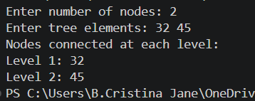

13. Implement a priority queue using a binary search tree and perform the operation Insert.

#include <stdio.h>
#include <stdlib.h>

struct node {
int priority;
struct node *left, *right;
};

struct node *insert(struct node *root, int p) {
if (root == NULL) {
struct node *newnode =
(struct node *)malloc(sizeof(struct node));

newnode->priority = p;
newnode->left = NULL;
newnode->right = NULL;

return newnode;
}

if (p < root->priority)
root->left = insert(root->left, p);
else if (p > root->priority)
root->right = insert(root->right, p);
else
printf("Priority already exists\n");

return root;
}

void display(struct node *root) {
if (root != NULL) {
display(root->left);
printf("%d ", root->priority);
display(root->right);
}
}

int main() {
struct node *root = NULL;
int n, p;

printf("Enter number of elements: ");
scanf("%d", &n);

for (int i = 0; i < n; i++) {
printf("Enter priority: ");
scanf("%d", &p);
root = insert(root, p);
}

printf("Priority queue (sorted order): ");
display(root);
printf("\n");

return 0;
}

OUTPUT:

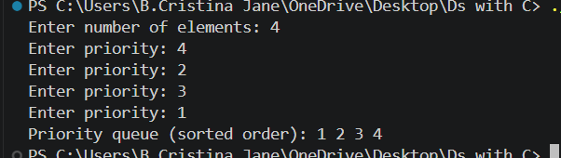

14. In a given binary search tree write a routines to delete a node with no children, one child and two children

#include <stdio.h>
#include <stdlib.h>

struct node {
int data;
struct node *left, *right;
};

struct node *insert(struct node *root, int x) {
if (root == NULL) {
struct node *newnode =
(struct node *)malloc(sizeof(struct node));

newnode->data = x;
newnode->left = NULL;
newnode->right = NULL;

return newnode;
}

if (x < root->data)
root->left = insert(root->left, x);
else if (x > root->data)
root->right = insert(root->right, x);

return root;
}

struct node *findMin(struct node *root) {
while (root->left != NULL)
root = root->left;

return root;
}

struct node *deleteNode(struct node *root, int key) {
if (root == NULL)
return NULL;

if (key < root->data)
root->left = deleteNode(root->left, key);

else if (key > root->data)
root->right = deleteNode(root->right, key);

else {
// Case 1: No children
if (root->left == NULL && root->right == NULL) {
free(root);
return NULL;
}

// Case 2: One child
else if (root->left == NULL) {
struct node *temp = root->right;
free(root);
return temp;
}

else if (root->right == NULL) {
struct node *temp = root->left;
free(root);
return temp;
}

// Case 3: Two children
else {
struct node *temp = findMin(root->right);
root->data = temp->data;
root->right = deleteNode(root->right, temp->data);
}
}

return root;
}

void inorder(struct node *root) {
if (root != NULL) {
inorder(root->left);
printf("%d ", root->data);
inorder(root->right);
}
}

int main() {
struct node *root = NULL;
int n, x, key;

printf("Enter number of nodes: ");
scanf("%d", &n);

printf("Enter elements: ");
for (int i = 0; i < n; i++) {
scanf("%d", &x);
root = insert(root, x);
}

printf("Enter node to delete: ");
scanf("%d", &key);

root = deleteNode(root, key);

printf("BST after deletion: ");
inorder(root);
printf("\n");

return 0;
}

OUTPUT:

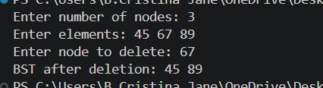

15. Convert the given postfix expression to an expression tree

#include <stdio.h>
#include <stdlib.h>
#include <ctype.h>

struct node {
char data;
struct node *left, *right;
};

struct node *stack[100];
int top = -1;

struct node *create(char c) {
struct node *n = malloc(sizeof(struct node));
n->data = c;
n->left = n->right = NULL;
return n;
}

int main() {
char exp[100];

printf("Enter postfix expression: ");
scanf("%99s", exp);

for (int i = 0; exp[i] != '\0'; i++) {
char c = exp[i];
struct node *n = create(c);

if (isalnum((unsigned char)c)) {
stack[++top] = n;
} else {
n->right = stack[top--];
n->left = stack[top--];
stack[++top] = n;
}
}

struct node *root = stack[top];

printf("Expression tree created successfully\n");
printf("Root operator: %c\n", root->data);
printf("Left child: %c\n", root->left->data);
printf("Right child: %c\n", root->right->data);

return 0;
}

OUTPUT:

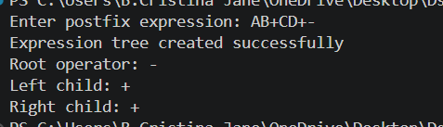

16. Construct binary search tree using (i)inorder node representation,(ii) preorder and (iii)postorder

#include <stdio.h>
#include <stdlib.h>

struct node {
int data;
struct node *left, *right;
};

struct node *insert(struct node *root, int x) {
if (root == NULL) {
struct node *newnode =
(struct node *)malloc(sizeof(struct node));

newnode->data = x;
newnode->left = NULL;
newnode->right = NULL;

return newnode;
}

if (x < root->data)
root->left = insert(root->left, x);
else if (x > root->data)
root->right = insert(root->right, x);

return root;
}

void inorder(struct node *root) {
if (root != NULL) {
inorder(root->left);
printf("%d ", root->data);
inorder(root->right);
}
}

void preorder(struct node *root) {
if (root != NULL) {
printf("%d ", root->data);
preorder(root->left);
preorder(root->right);
}
}

void postorder(struct node *root) {
if (root != NULL) {
postorder(root->left);
postorder(root->right);
printf("%d ", root->data);
}
}

int main() {
struct node *root = NULL;
int n, x, i;

printf("Enter number of nodes: ");
scanf("%d", &n);

printf("Enter elements: ");
for (i = 0; i < n; i++) {
scanf("%d", &x);
root = insert(root, x);
}

printf("Inorder traversal: ");
inorder(root);

printf("\nPreorder traversal: ");
preorder(root);

printf("\nPostorder traversal: ");
postorder(root);

printf("\n");

return 0;
}
OUTPUT:

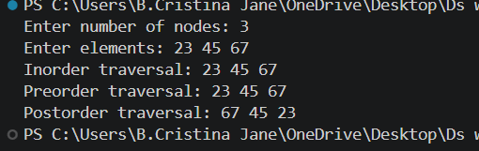

17. Implement heap sort for a set of numbers

#include <stdio.h>

void heapify(int a[], int n, int i) {
int largest = i;
int left = 2 * i + 1;
int right = 2 * i + 2;
int temp;

if (left < n && a[left] > a[largest])
largest = left;

if (right < n && a[right] > a[largest])
largest = right;

if (largest != i) {
temp = a[i];
a[i] = a[largest];
a[largest] = temp;

heapify(a, n, largest);
}
}

void heapSort(int a[], int n) {
int temp;

for (int i = n / 2 - 1; i >= 0; i--)
heapify(a, n, i);

for (int i = n - 1; i > 0; i--) {
temp = a[0];
a[0] = a[i];
a[i] = temp;

heapify(a, i, 0);
}
}

int main() {
int a[100], n;

printf("Enter number of elements: ");
scanf("%d", &n);

printf("Enter elements: ");
for (int i = 0; i < n; i++)
scanf("%d", &a[i]);

heapSort(a, n);

printf("Sorted elements: ");
for (int i = 0; i < n; i++)
printf("%d ", a[i]);

printf("\n");
return 0;
}

OUTPUT:

